Temple Inn & Suites Site Plan

# Site Basics

**Site name:** templeinn.com

**Site Purpose:** The Temple Inn & Suites is a hotel chain headquartered in Bethesda, MD that builds and manages specialized hotel accommodations near temple locations of The Church of Jesus Christ of Latter-day Saints around the world. The owner-operated company caters to temple workers, patrons, and their families by providing specialized services and accommodations that meet the needs of those patrons. The hotel accommodations and services are available to anyone willing to abide by the terms and policies outlined by the company.

The overall goal of the website project is to promote and provide information about the specialized services that this hotel chain offers to meet the needs of temple patrons who come to serve in the temple or who participate in events such as sealings, weddings, receptions, and youth trips. The website should reflect the Church culture and be designed to support a temple oriented theme as well as the concept of being a haven of comfort and accessibility.

**Target Audience:** temple patrons who come to serve in the temple or who participate in events such as sealings, weddings, receptions, and youth trips.

## Personas

**Persona 1:** Temple worker

**Persona 2:** Temple attendee – no kids

**Persona 3**: Youth Leader

**Persona 4**: Engaged couple planning sealing/wedding

**Persona 5**: Parents who want to attend temple on vacation but need help with child care

## Scenarios:

Longer term residency for temple workers

Reception hall for weddings / sealings

Child care for parents

# Color Scheme

Need to narrow down, possibly from this list

Colors in Palette

|  |  |  |
| --- | --- | --- |
| **Color** | **Hex** | **RGB** |
|  | [#727272](https://www.color-hex.com/color/727272) | (114,114,114) |
|  | [#f9ecff](https://www.color-hex.com/color/f9ecff) | (249,236,255) |
|  | [#f2d9fb](https://www.color-hex.com/color/f2d9fb) | (242,217,251) |
|  | [#cbffe8](https://www.color-hex.com/color/cbffe8) | (203,255,232) |
|  | [#b7f4da](https://www.color-hex.com/color/b7f4da) | (183,244,218) |

# Typography

|  |  |  |  |  |  |
| --- | --- | --- | --- | --- | --- |
| Attribute | Font Family | Size | Color | Background Color | Sample |
| Site Header | Satisfy | 40px | Grey | White | Sample |
| Primary Navigation | Open Sans | 30px | Grey | White | Sample |
| Footer Navigation | Open Sans | 20px | Grey | White | Sample |
| Heading 1 (h1) | Satisfy | 30px | Grey | White | Sample |
| Heading 2 (h2) | Satisfy | 25px | Grey | White | Sample |
| Heading 3 (h3) | Open Sans | 20px | Grey | White | Sample |
| Paragraph text (p) | Open Sans | 16px | Grey | White | Sample |

Standard html:

<style>  
@import url('https://fonts.googleapis.com/css?family=**Open+Sans|Satisfy**');  
</style>

@import:

<style>  
@import url('https://fonts.googleapis.com/css?family=**Open+Sans|Satisfy**');  
</style>

CSS:

font-family: 'Satisfy', cursive;

font-family: 'Open Sans', sans-serif;

# Site map

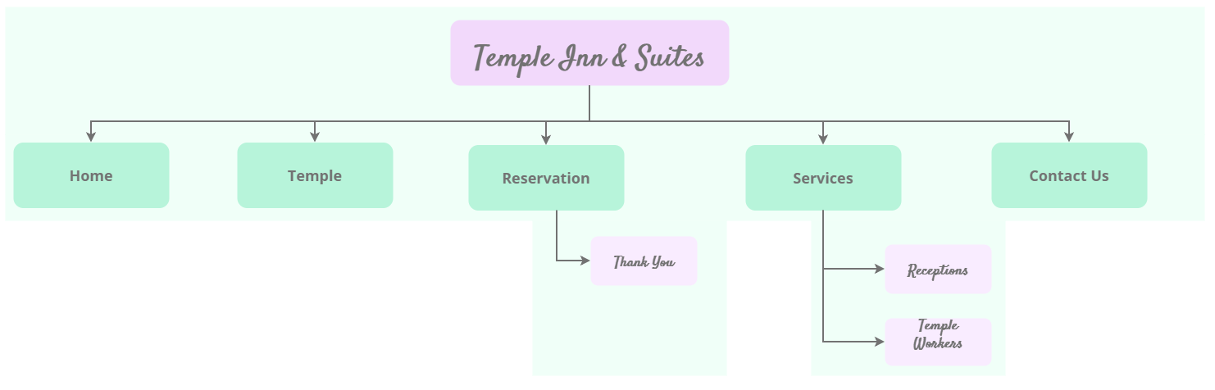

Wireframes

## Home Page

Include:

* Temple images
* Temple activity images
* Call to action to make a reservation
* Readily available nav and contact info
* Summary info about a temple of choice

Small

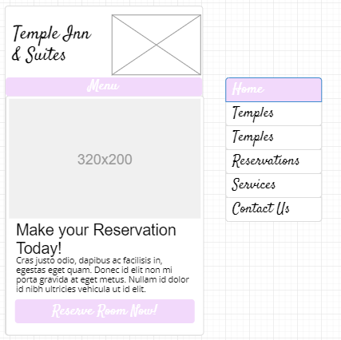

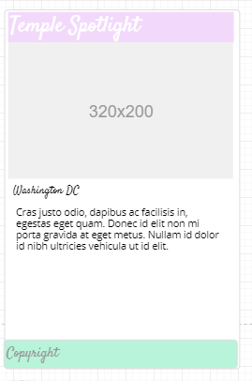

Medium

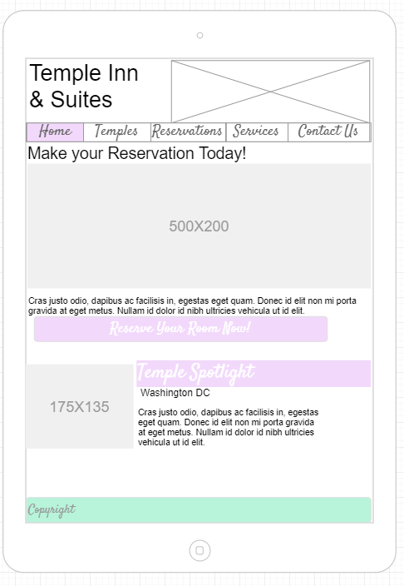

Large

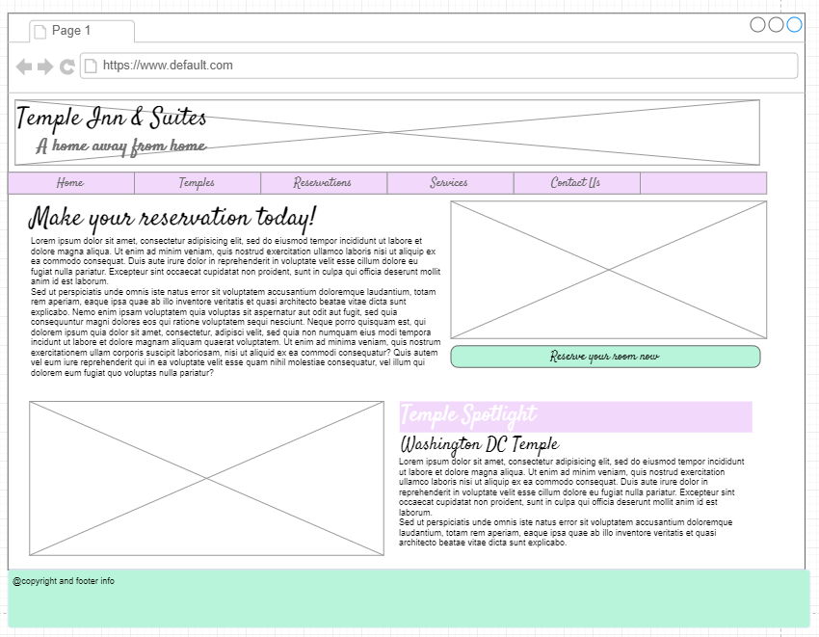

## Temple page

Include 4 temples

* Address
* Telephone
* Email
* Services
* History
* Ordinance schedule
* Session schedule
* Closure schedule
* Summary – current weather info

## Reservation page

Include

* Form to complete
* Location
* Date
* Number and type of rooms
* Registrants full name
* Email
* Phone
* Home state or country
* Special accomodations

## Services page

Include

* List of amenities
* Sub pages for Reception and Full time Missionaries

### Reception

* Food service
* Set up

### Full time missionary

* Info
* Images
* Contact us form

## Contact page

* Google map
* Contact info